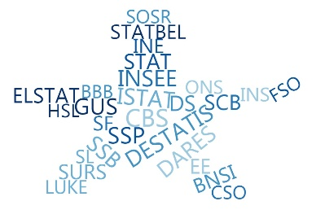

**ESSnet Big Data II**

**Grant Agreement Number:**

**NUMBER — 847375 — 2018-NL-BIGDATA**

<https://webgate.ec.europa.eu/fpfis/mwikis/essnetbigdata>

[<https://ec.europa.eu/eurostat/cros/content/essnetbigdata_en>](https://ec.europa.eu/eurostat/cros/content/essnetbigdata_en)

**Workpackage WPB**

**Implementation – Online Job Vacancies**

**Labour Market Concentration Indicators**

**using Online Job Ad Data**

|  |
| --- |
| **Prepared by: Jakob de Lazzer (DESTATIS, Germany)** |

Workpackage Leader:

Tomaž Špeh (SURS, SI )

e-mail address: tomaz.speh@gov.si

mobile phone: +38651672116

**Table of contents**

1. Initial considerations 4

2. Functional Urban Areas 5

3. Construction of the index 5

4. Results 6

5. References 10

**Figures**

Figure 1 7

**Tables**

Table 1 Summary of concentration index 6

Table 2 LM-concentration index table (FUA) 7

# Initial considerations

While market power due to monopolies and monopsonies in product markets is well documented and regulated by antitrust agencies, monopsony power and market concentration in labour markets is rarely in the spotlight. In part because empirical evidence of labour market concentration has historically been scarce due to lack of suitable data. In recent years however, public interest in labour market monopsony power has increased and several studies have shown that labour market concentration is widespread and has significant consequences.[1] Concentrated labour markets allow employers to offer wages below worker’s marginal productivity, depress the wage distribution and generate rents just like in concentrated product markets.[2] If, for a given occupation, region and timeframe, few potential employers are offering jobs, they can force workers to accept lower wages since the wage elasticity of labour supply is generally low (at least in the short run).[3]

Concentration in labour markets does not necessarily overlap with concentration in product markets. Labour market competition is measured at the level of worker occupation and is limited by worker mobility. Employees can face a concentrated local labour market even if they work in a sector where products markets are highly competitive nationwide or internationally. On the other hand, product monopolists might compete against employers in other product markets for the same employees.

Against a background of stagnating median real wages and slowly increasing product market power in Germany, the wage effects of labour market monopsony power cannot be taken lightly.[4] Therefore, the topic of market concentration has high policy relevance and German policymakers have shown a willingness to expand the scope of antitrust laws to cover new markets.[5]

Data on online job ads is uniquely suited for detecting and monitoring labour market concentration. Ideally, we would observe the universe of job ads, in order to quantify market shares of all employers in each local labour market. Online job ad data collected by CEDEFOP comes reasonably close to this ideal, with 15,578,258 distinct job ads over three quarters from a wide range of online sources across the entire country and all occupations.[6] CEDEFOP job ad data also contains the necessary information about the location, the company and the occupation of the job.[7]

This data allows us to quantify the share of job offers for each employer by occupation and timeframe in local labour markets. From this data, one can calculate measures of market concentration like market shares or the Herfindahl-Hirschman-Index. Such indices of market concentration can be evaluated by the criteria used by antitrust agencies in order to classify markets as critically concentrated.

We propose a labour market concentration index (LMC) which can be published each quarter and can inform educational, regional and labour market policy.

# Functional Urban Areas

We define local labour markets in terms of Functional Urban Areas (FUA) as used by Eurostat.[8] A FUA consists of one or more cities and their commuting zone. Commuting zones are based on commuting patterns. If at least 15% of the population of a local administrative unit (sub-region) commute to a city, the unit is classified as part of the commuting zone. If no large numbers of individuals commute from outside the city, the city itself is a FUA (E.g. Tübingen). A FUA represents the area within which the majority of inhabitants would look for jobs. Searching outside their FUA is likely to require moving, which is costly, and would therefore require a high wage premium to be beneficial. The Eurostat definition lists 118 unique FUA codes for Germany.[9] Of these, 11 are missing in our data, meaning that no job ad observations are available. In at least one case this is likely due to geographical miscoding in CEDEFOP data and will need to be resolved in the final index.

# Construction of the index

Our labour market concentration index (LMC) is based on the considerations by Azar et al. (2018) and employs a similar methodological approach. Relevant labour markets are defined in terms of geography, timeframe and occupation. The geographical unit of choice is the functional urban area (FUA).[10] The principal advantage of FUAs is that they contain both living and working areas within commuting zones and are therefore uniquely suited to define local labour markets. The timeframe for analysis are quarter years. Occupations are classified by the ISCO level 4 scheme.

The actual index is the sum of squared market shares across all employers in a given local labour market in a given quarter. It is calculated for quarter (t) with squared market shares (s) for employers (i) in a given market (j):

$${LMC}_{jt}=\sum_{i}{s_{ijt}^{2}}$$

The index has a range from 0 to 10000, with 0 denoting perfect competition and 10000 denoting a monopoly. The index is the labour market equivalent of the Herfindahl-Hirschmann Index (HHI) for product markets. The HHI is used as a secondary metric for evaluating mergers by the German antitrust agency (Bundeskartellamt), although they primarily rely on the size of market shares by the largest companies. One of the main benefits of these indices is that they can be easily compared across markets and over time.

# Results and next steps

The LMC is estimated as a labour market concentration index for the timeframe from q3-2018 to q1-2019, for each ISCO-4 occupation and functional urban area in Germany. Table 1 shows summary statistics of the LMC averaged across quarters and regions. The mean LMC across three quarters and all occupation/region cells is 3686 and the median is 2400. In several occupation/region/quarter cells, the LMC reaches a maximum of 10000, indicating a monopoly in the respective occupational local labour market.

In order to interpret these values, consider the following: For merger control at the European level, LMC values between 1000 and 2000 are considered non-critical.[11] In US antitrust proceedings, markets with LMCs below 1500 are considered not concentrated and those above 2500 are considered highly concentrated.[12] A highly concentrated market would have only four active companies, if market shares were evenly distributed. Therefore half of all occupation/region/quarter cells can be considered concentrated because their LMC lies above 2500. And there are even some local occupational labour markets where a single employer has a monopoly on job offers.

Table 1 Summary of concentration index

|  |  |
| --- | --- |
| Metric | LMC |
| mean | 3686 |
| minimum | 83 |
| 50th percentile (median) | 2400 |
| 48th percentile | 2500 |
| maximum | 10,000 |

Figure 1 shows the geographical distribution of average labour market concentration indices by functional urban area, averaged across three quarters. It is apparent that there are substantial differences in the average concentration of labour markets between regions, which suggests that some markets are inherently competitive, while others are not. The regional differences are stable over time and hardly change between quarters. This fact indicates that temporary hiring waves are not a major determinant of labour market concentration. Instead, the structure of employers in each region determines LMC.

Examples of competitive markets are the urban regions of Berlin, Hamburg, Düsseldorf and Stuttgart. Examples of non-competitive markets are rural regions like Mecklenburg-Vorpommern or Niederbayern, but also regions with medium sized cities like Lüneburg, Marburg or Tübingen.

These results show that some labour markets in Germany are highly concentrated. The next step in the analysis would be to establish a link between market concentration and wage levels in local labour markets. The strength of the relation between wages and LMC, while controlling for regional characteristics, would give some indication of the wage impact of labour market concentration. Two data sources, both available from the federal employment agency, might be suitable for this purpose. The best option, the SIAB dataset, containing a 2% sample of all dependent employees with high quality information about wages, occupations and places of work, is not yet available for 2018 and 2019. Once it becomes available, this should be the primary resource for linking wages to LMC. Until then, I plan on using the statistic of gross employment remuneration, which provides median wages by region and rough occupational classification.[13]

Figure 1

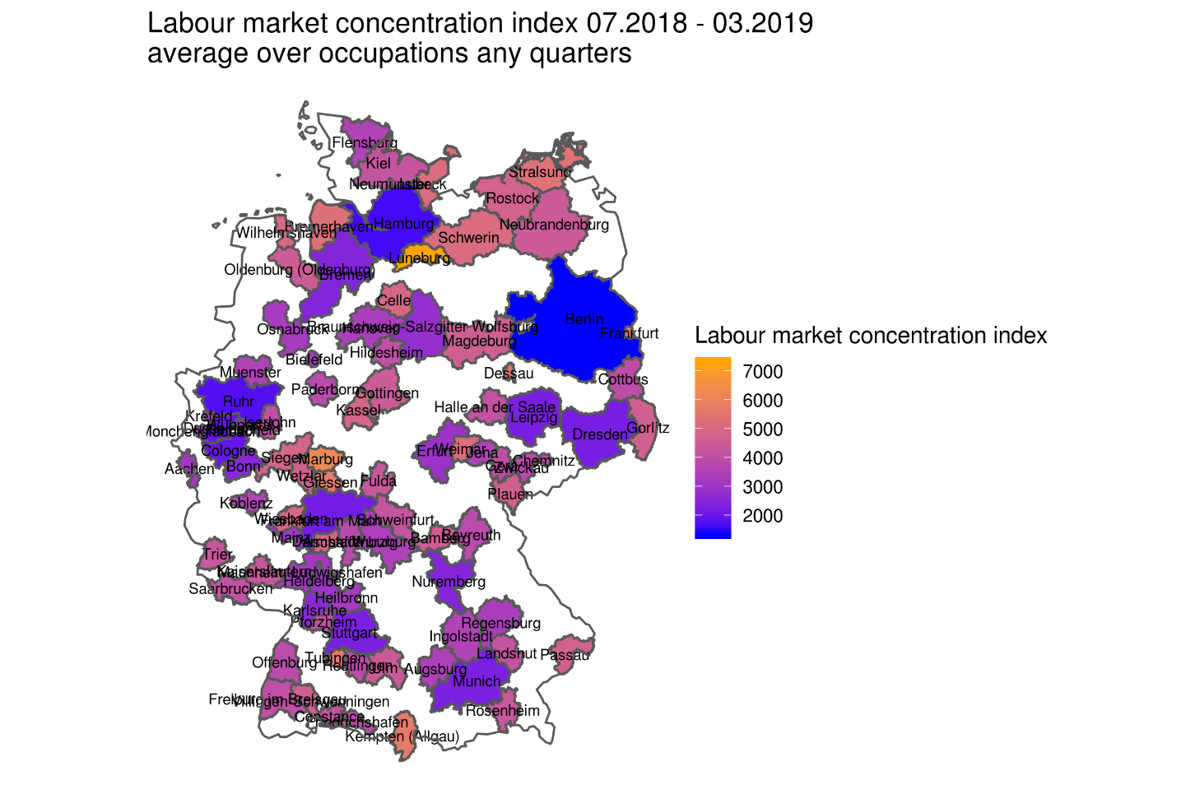

Table 2 LM-concentration index table (FUA)

|  |  |  |  |  |  |
| --- | --- | --- | --- | --- | --- |
|  | FUA (functional urban area) | Name | Avg. Q3 2018 | Avg. Q4 2018 | Avg. Q1 2019 |
| 1 | DE001 | Berlin | 1277 | 1380 | 1336 |
| 2 | DE002 | Hamburg | 1632 | 1587 | 1377 |
| 3 | DE003 | Munich | 2565 | 2458 | 2338 |
| 4 | DE004 | Cologne | 2032 | 1825 | 1714 |
| 5 | DE005 | Frankfurt am Main | 2059 | 2045 | 1935 |
| 6 | DE007 | Stuttgart | 2473 | 2158 | 2075 |
| 7 | DE008 | Leipzig | 2399 | 2033 | 2045 |
| 8 | DE009 | Dresden | 2371 | 1955 | 2047 |
| 9 | DE011 | Dusseldorf | 2035 | 1704 | 1955 |
| 10 | DE012 | Bremen | 2429 | 2258 | 2290 |
| 11 | DE013 | Hanover | 3326 | 3377 | 3346 |
| 12 | DE014 | Nuremberg | 2402 | 2280 | 2336 |
| 13 | DE017 | Bielefeld | 3330 | 2992 | 3118 |
| 14 | DE018 | Halle an der Saale | 3968 | 3927 | 4053 |
| 17 | DE019 | Magdeburg | 5006 | 4518 | 4394 |
| 18 | DE020 | Wiesbaden | 5115 | 4919 | 4596 |
| 20 | DE021 | Gottingen | 4330 | 4585 | 4356 |
| 21 | DE025 | Darmstadt | 4796 | 4720 | 4487 |
| 23 | DE026 | Trier | 4376 | 4031 | 4229 |
| 24 | DE027 | Freiburg im Breisgau | 4151 | 3751 | 4011 |
| 25 | DE028 | Regensburg | 3527 | 3427 | 2973 |
| 26 | DE029 | Frankfurt | 7037 | 5198 | 5373 |
| 27 | DE030 | Weimar | 5163 | 5157 | 4890 |
| 28 | DE031 | Schwerin | 5153 | 5039 | 4777 |
| 29 | DE032 | Erfurt | 3026 | 2683 | 2704 |
| 30 | DE033 | Augsburg | 3495 | 3232 | 3176 |
| 31 | DE034 | Bonn | 2531 | 2214 | 2370 |
| 32 | DE035 | Karlsruhe | 2583 | 2646 | 2386 |
| 33 | DE036 | Monchengladbach | 3723 | 3173 | 3206 |
| 35 | DE037 | Mainz | 3052 | 2887 | 2719 |
| 36 | DE038 | Ruhr | 1675 | 1670 | 1621 |
| 37 | DE039 | Kiel | 4272 | 3926 | 4007 |
| 38 | DE040 | Saarbrucken | 4312 | 3858 | 4037 |
| 39 | DE042 | Koblenz | 3560 | 3372 | 3604 |
| 40 | DE043 | Rostock | 5000 | 4857 | 4304 |
| 41 | DE044 | Kaiserslautern | 4181 | 4260 | 4153 |
| 42 | DE045 | Iserlohn | 4109 | 3988 | 3978 |
| 43 | DE048 | Wilhelmshaven | 4727 | 5155 | 4831 |
| 44 | DE050 | Tubingen | 5992 | 5410 | 5169 |
| 45 | DE051 | Villingen-Schwenningen | 4651 | 4701 | 4484 |
| 46 | DE052 | Flensburg | 3454 | 3477 | 3479 |
| 47 | DE053 | Marburg | 6158 | 6250 | 5956 |
| 48 | DE054 | Constance | 4402 | 4161 | 3910 |
| 49 | DE055 | Neumunster | 4622 | 4418 | 4366 |
| 50 | DE057 | Giessen | 5863 | 5745 | 5520 |
| 52 | DE058 | Luneburg | 7360 | 7141 | 7270 |
| 55 | DE059 | Bayreuth | 3746 | 3735 | 3830 |
| 56 | DE060 | Celle | 5161 | 4772 | 4599 |
| 57 | DE061 | Aschaffenburg | 3646 | 3746 | 3679 |
| 58 | DE062 | Bamberg | 4753 | 4335 | 4589 |
| 59 | DE063 | Plauen | 4906 | 4375 | 4290 |
| 60 | DE064 | Neubrandenburg | 4401 | 4229 | 4457 |
| 61 | DE065 | Fulda | 4321 | 4105 | 4037 |
| 62 | DE066 | Kempten (Allgau) | 5821 | 5706 | 5501 |
| 64 | DE067 | Landshut | 4225 | 3999 | 3821 |
| 66 | DE069 | Rosenheim | 4110 | 4289 | 4009 |
| 68 | DE071 | Stralsund | 5502 | 5360 | 5052 |
| 69 | DE072 | Friedrichshafen | 3923 | 3910 | 3701 |
| 70 | DE073 | Offenburg | 3809 | 4002 | 3812 |
| 71 | DE074 | Gorlitz | 4859 | 4966 | 4392 |
| 72 | DE077 | Schweinfurt | 4380 | 4007 | 3767 |
| 73 | DE079 | Wetzlar | 4889 | 4276 | 4717 |
| 74 | DE081 | Passau | 5012 | 4759 | 4447 |
| 75 | DE082 | Dessau | 5415 | 5562 | 5789 |
| 76 | DE083 | Braunschweig-Salzgitter Wolfsburg | 2848 | 2407 | 2714 |
| 78 | DE084 | Mannheim-Ludwigshafen | 3345 | 2891 | 2991 |
| 79 | DE504 | Muenster | 4108 | 2978 | 2962 |
| 80 | DE505 | Chemnitz | 4047 | 3497 | 3682 |
| 81 | DE507 | Aachen | 3265 | 2951 | 3007 |
| 82 | DE508 | Krefeld | 3473 | 3169 | 3525 |
| 83 | DE510 | Lubeck | 5237 | 5116 | 5230 |
| 84 | DE513 | Kassel | 4808 | 4868 | 5033 |
| 86 | DE517 | Osnabruck | 3270 | 3073 | 3129 |
| 87 | DE520 | Oldenburg (Oldenburg) | 4669 | 4457 | 4274 |
| 88 | DE522 | Heidelberg | 3050 | 2797 | 2846 |
| 89 | DE523 | Paderborn | 3710 | 3834 | 3825 |
| 90 | DE524 | Wurzburg | 3734 | 3191 | 3227 |
| 91 | DE527 | Bremerhaven | 5582 | 5106 | 4817 |
| 92 | DE529 | Heilbronn | 3219 | 3168 | 2930 |
| 93 | DE530 | Remscheid | 4407 | 4039 | 4207 |
| 94 | DE532 | Ulm | 4434 | 4437 | 4390 |
| 96 | DE533 | Pforzheim | 4048 | 4003 | 3993 |
| 97 | DE534 | Ingolstadt | 3590 | 3749 | 3098 |
| 98 | DE535 | Gera | 4075 | 3749 | 3856 |
| 99 | DE537 | Reutlingen | 3873 | 4085 | 3603 |
| 101 | DE539 | Cottbus | 4115 | 3779 | 3585 |
| 104 | DE540 | Siegen | 4783 | 4819 | 4818 |
| 105 | DE542 | Hildesheim | 4018 | 3977 | 3905 |
| 106 | DE544 | Zwickau | 3838 | 3653 | 3750 |
| 108 | DE546 | Wuppertal | 3280 | 3023 | 3003 |
| 109 | DE547 | Jena | 3687 | 3297 | 3303 |

# References

**Ashenfelter, O., Farber, H., Ransom, M.,** (2010): Labor Market Monopsony, *Journal of Labor Economics* 28, no. 2: 203-210.

**Azar, J. Marinescu, I. Steinbaum, M. Taska, B.**,(2018): Concentration in US Labor Markets: Evidence From Online Vacancy Data, *NBER working paper* No. 24395.

**Biewen, M., Fitzenberger, B., de Lazzer, J.,** (2018): The role of employment interruptions and part-time work for the rise in wage inequality. *IZA Journal of Labor Economics*, 7(1):10.

**Card, D., Heining, J., Kline, P.**, (2013): Workplace heterogeneity and the rise of West German wage inequality. *The Quarterly Journal of Economics*, 128(3):967–1015.

**Dustmann, C., Ludsteck, J., Schönberg, U.**, (2009): Revisiting the German wage structure. *The Quarterly Journal of Economics*, 124:843–881.

**Falch, T**., (2010): The Elasticity of Labor Supply at the Establishment Level, *Journal of Labor Economics*, 28(2): 237-266.

**Staiger, D. Spetz, J. Phibbs, C**., (2010): Is there monopsony power in the labor market? Evidence from a natural experiment, *Journal of Labor Economics*, 28(2): 211-236.

**GWB (2017**), 9. Novelle des Gesetzes gegen Wettbewerbsbeschränkungen, *Bundesgesetzblatt* Teil I Nr. 33, Bonn“.

**Manning, A**., (2011): Imperfect competition in the labor market. *Handbook of labor economics*, 4: 973-1041*.*

1. Azar et al. (2018), Staiger and Spetz (2010), Falch (2010).
2. Compare Manning (2011).
3. Compare Ashenfelter et al. (2010).
4. Compare Dustmann (2009), Card (2013) and Biewen (2018) and Monopolkommission (2018).
5. Compare GWB (2017).
6. The companion report to this article, Destatis (2019), “CEDEFOP exploratory analysis”, documents gaps and inconsistencies in the current version of CEDEFOP OJA data. The documented issues are not detrimental to the quality of the concentration index. Particularly, the problem of possible duplicate observations has no impact on the concentration index, as long as the frequency of duplicates is not correlated with employer market shares. Of more pressing concern is the under-representation of the construction sector in OJA data. However, when performing the analysis omitting the construction sector, the results are almost identical. Furthermore, considering the continuing efforts by CEDEFOP to improve their data collection and preparation procedures, I expect these issues to be resolved in the medium term.
7. For a fraction of observations information about the company is missing. These observations are treated as belonging to synthetic employers, each of which offers the median number of job, in order to not distort the concentration index.
8. Eurostat Glossary:Functional urban area, accessed 10.02.2020, https://ec.europa.eu/eurostat/statistics-explained/index.php/Glossary:Functional_urban_area
9. Because CEDEFOP data does not contain geographical identifiers for FUAs, we merge FUAs by NUTS 3 level.
10.
11. Leitlinien zur Bewertung horizontaler Zusammenschlüsse gemäß der Ratsverordnung über die Kontrolle von Unternehmenszusammenschlüssen (2004/C 31/03).
12. DOJ/FTC, Horizontal Merger Guidelines, 19. August 2010.
13. „Statistik der Bruttoarbeitsentgelte“.